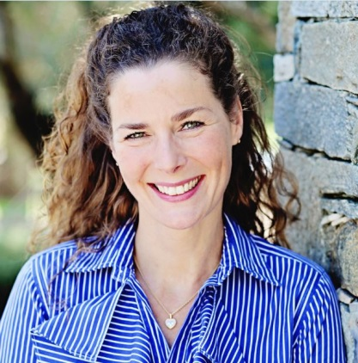

Pernille HENRIKSEN

[Danish patient organisation for lymphedema (DALYFO)](https://dalyfo.dk/)

Established in 1992, DALYFO is a Danish association representing patients with primary and secondary lymphoedema. We have strong ties and collaborations with the other Nordic patient associations for lymphoedema and the Danish Lymphoedema Framework.